Short-beaked common dolphin (Delphinus delphis) mortality.

The short-beaked common dolphin (Delphinus delphis) is one of the most abundant cetacean species in the eastern North Atlantic (SCANS-II, 2008). It is considered a single population since no evidence of genetic structuring has been found in the area (e.g. Murphy et al., 2013). Some life history parameters: sexual maturity, life expectancy and pregnancy rate have been derived from post-mortem data obtained from stranded and by-caught individuals. In addition to these, parameters such as mortality-at-age are unknown but needed to estimate population dynamics.

Previous analysis were made applying some approaches for estimating natural mortality in long-living species, based on the longevity (Hoenig, 1983; Hewitt and Hoenig, 2005) and weight (Charnov, 1993) (Table 1).

Table 1: Mortality models for long-lived species. Based on the longevity (Hoenig, 1983; Hewitt and Hoenig, 2005) and weight (Charnov, 1993)

Nevertheless, it is known that marine mammals show a different mortality rate according to age, suffering high mortality at young ages, followed by lower and constant mortality which increases again at older ages. For this reason, mortality rate in mammals has been usually approximated using life table methodology (i.e. Pierce et al., 2013, poster Setubal, Read et al., 2012, harbour porpoises ASCOBANS report). A life table is a vector of age-specific survival or mortality rates, and represents an important tool for understanding the demography of populations (Stolen and Barlow, 2003). Survivorship and mortality can be inferred directly by following one or more cohorts through time, or indirectly from analysis of an age distribution of living individuals (Caughley, 1966; Barlow and Boveng, 1991) or from the age distribution of deaths (Caughley, 1966; Spinage, 1972).

Although widely used for terrestrial and some marine mammals (Spinage, 1972; Hewer, 1974; Marmontel, 1993), few mortality models based on life tables have been constructed for cetaceans (Olesiuk, 1990; Barlow and Boeng, 1991; Brault and Caswell, 1993; Barlow and Clapham, 1997; Stolen and Barlow, 2003) .

Using data from stranded animals we can construct life tables that, although they may have some restrictions, are often approximated well enough for practical purposes (Stolen and Barlow, 2003). Based on this assumption, we constructed a life table from data from stranded carcasses from Galician coast (Northwest Spain) collected by CEMMA (Coordinadora para o Estudio dos Mamíferos Mariños) from 1990 to 2010, and age-at-death data estimated by Fiona Read by counting the age layer groups present in the teeth gathered from the carcasses.

However, the possible biases arising from the use of stranding data should be taken into account. For example, not all carcasses might arrive at the coast, especially those of small/younger animals that could be more vulnerable to predation, more rapidly decomposed and/or have lower detection probability (Stolen and Barlow, 2003). For this reason, several models have been used to fit a smooth age-specific mortality function such an exponential model, general linear model (GLM) family Poisson, a second-degree polynomial and the Siler model (Siler, 1979), using a maximum likelihood method.
Strandings models

Four models were applied to fit total mortality in the common dolphin subpopulation off the Northwest coast of the Iberian Peninsula. The fitted models were an exponential model, a GLM family Poisson, a second-degree polynomial model, and the Siler model mentioned above. While first three models were fitted directly from the total amount of stranded-at-age dolphins, the fit of the last was conducted using mortality-at-age obtained from a life table previously constructed from the stranding raw data. In all cases, the models were first run with all the available data and afterwords models were rerun after removing the younger age classes sequentially, accordingly, each of the four models were fitted from four data sets of different sizes (Figure 1).
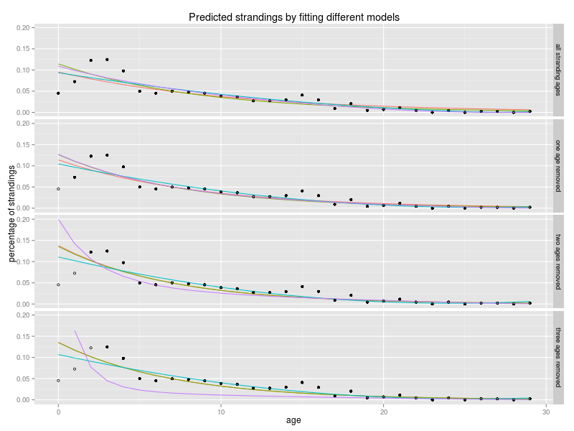
Figure 1: Predicted strandings applying different models: Exponential model (red), GLM family Poisson model (green), second-degree polynomial model (blue), and the Siler model (purple). Models fitted with all the available data and fitted after removing the younger age classes (none, one, two and three age classes). Total stranded dolphins used to fit the model (black dots) and stranded dolphins removed (circles).

Worthy of note is that Siler model shows slightly different patterns. Siler model is a three component competing-risk model for animal mortality, in which the addictive hazards include a new model, dominant during the prematurity period; a constant hazard, dominant during the period of maturity; and the conventional Gompertz hazard, dominant during senescence. To fit the negative exponential model, ages through 8 (immature animals) were used, rerunning the model after removing the younger age classes sequentially. Constant mortality corresponded to the mortality of the age 5, age at which mortality is lower. Positive exponential model for senescence animals was fitted using ages form 8 to 29. Age 8 was used to fit juvenile and senescence mortality because it is the age at which half the animals are mature. A good explanation of the three components and the contribution of each for the whole model can be visualized in Figure 2 for the model fitted with the data set where two ages were removed.
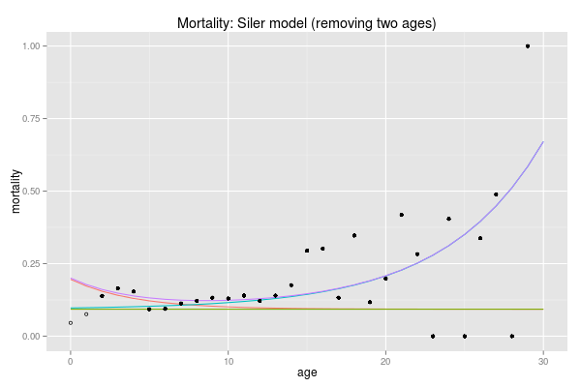
Figure 2: Mortality fitted with Siler competing-risk model. Siler mortality (Purple line), juvenile mortality (red line), constant mortality (green line), senescence mortality (blue line). Mortality-at-age in the raw data used to fit the model (dots), ad mortality-at-age in the raw data do not used to fit the model (circles).

While the exponential and the GLM give similar fits throughout all age classes and with data sets of all the sizes, the second-degree polynomial model overfits some values and gives unreal figures, chiefly in the last age classes. Life tables were constructed for each model to estimate the mortality-at-age. In Figure 3, can be appreciated that the predicted total mortality (Z) is quite similar between the exponential and GLM in the four different fits (by removing none, one, two and three of the first age classes) although mainly in the second and third cases. The second-degree polynomial shows a similar fit at the first ages to the others but a peculiar shape in the older age classes due to the overfitting and even, with the raw data set, were obtained negative values in abundance causing an unreal truncated line. Nevertheless, Siler model differs greatly at the earlier ages with the other models because it captures more precisely the differences in the earlier ages. Senescence mortality slope is more progressive than the other models so, it is not needed a big promotion at the end to achieve population balance. Nonetheless, the fit is not good with the raw data because the exponential model becomes positive instead negative due to lack of strandings data in the first age classes and, therefore, very low values. That leads to an increase in the mortality associated with senescence and therefore an error in the model which confirms that some of the first ages must be removed.

Comparing the same model fitted with the different data sets as we can see in Figure 4, big differences become evident in older age classes with the second-degree polynomial model fit, as explained above. However, slight variations occur when different datasets are fitted with the GLM and exponential model. Furthermore, that differences are very small with the GLM fit, therefore we can conclude that differences in the pattern of strandings are very small in the case of GLM fit regardless of number of young age classes we use. However, we have already seen that the Siler model shows large differences in the earliest ages with the other models, and also makes it between different data sets. This is due to the low number of data used to fit the negative exponential model which fits the juvenile mortality. Discarding the raw data fit, when only one class is removed, the number of strandings shows a small increase followed by a decrease. This leads to the conclusion that there is still a lack of data in that age class and therefore, mortality will be underestimated. The opposite occurs in the latter case, where too much age classes have been removed, and the slope of the fit grows too much, as the mortality of the first ages. For this reasons, the model where two age classes were removed seem to be the best and mortality of the first age classes appears reasonable. In any case, differences of the mortality in the first age classes seems high and could significantly affect to the population structure since in the first age classes is where are found the greatest number of individuals.
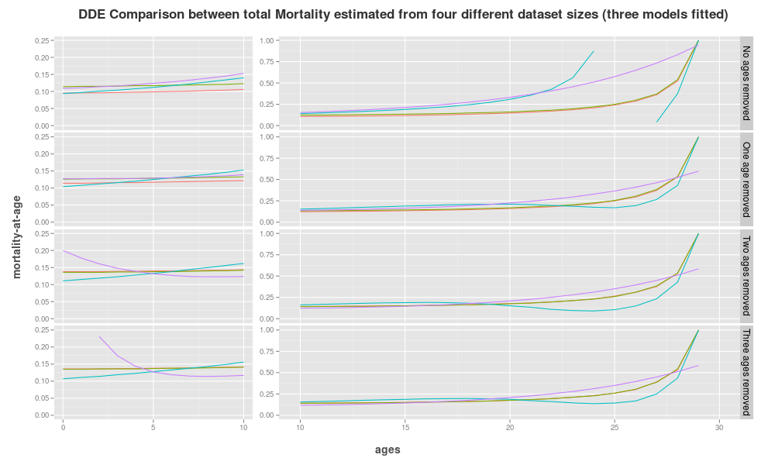
Figure 3: Predicted total mortality from four data sets of different sizes and four models and: Total mortality predicted from a life table constructed with an Exponential strandings model (red line), a GLM family Poisson (green line), a second-degree Polynomial model (blue line) and a Siler model (purple line). Each one of them fitted to total strandings data (No ages removed) and strandings data after removing the younger age classes sequentially, 0 (One age removed), 0 to 1 (Two ages removed), 0 to 2 (Three ages removed).
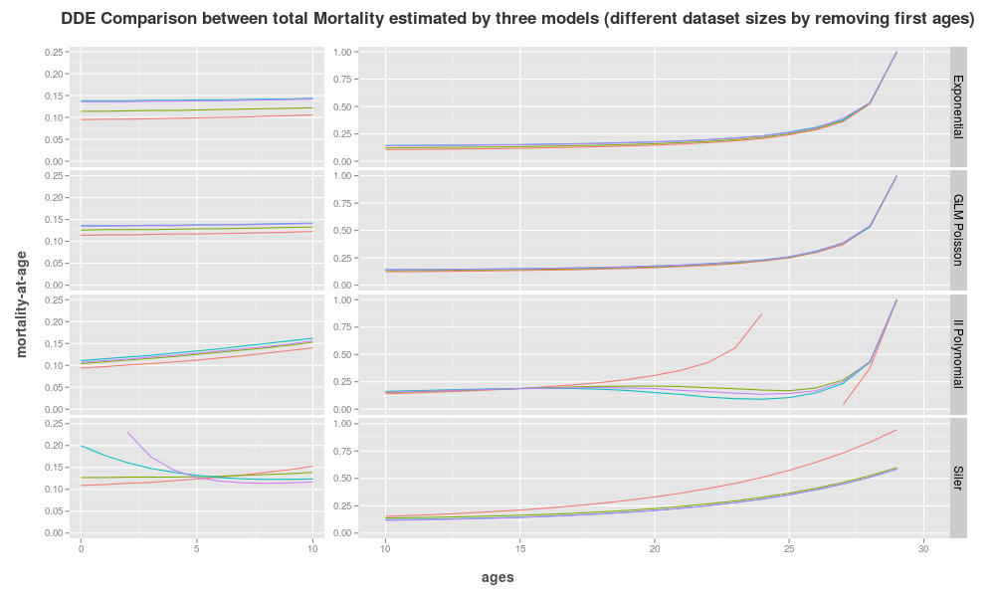
Figure 4: Predicted total mortality with four models and from four data sets of different sizes: Total mortality predicted from a life table constructed with an Exponential strandings model (Exponential), a GLM family Poisson (GLM Poisson), a second-degree polynomial model (II Polynomial) and a Siler model (Siler). Each one of them fitted with total strandings data (red line) and strandings data after removing the younger age classes sequentially, 0 (green line), 0 to 1 (blue line) and 0 to 2 (purple line).
Life tables

Life tables for each model were conducted. Assuming a stable population, life tables allow the construction of a theoretical population structure with a corresponding abundance by age and calculate the survivorship and mortality-at-age. Choosing the model with two ages removed as the one that best fits our data, survivorship and mortality differences can be compared from life tables between the raw data and both the Exponential fit, the GLM and the Siler model (Table 2).

Table 2: Survivorship and mortality-at-age from the raw data and from the predicted data fitted with the data set with two ages removed: Survivorship (S) and mortality (M) both from the raw strandings data (lifeN) and from the strandings predicted with the Exponential model (lifeExp2), the GLM (lifeglmPois2), the Polynomial model (lifeIIPol2) and from the predicted mortality of the Siler model (lifeSiler2).

In figure 5 survivorship and mortality are graphically represented. Mortality-at-age for the raw data is highly variable specially in older ages. By fitting the models this variations were smoothed. Differences between they can be observed in younger ages where Siler model estimates higher mortalities corresponding to the immature hazards explained above. Then, adult Siler mortality is slightly less than in the GLM and exponential models, and in the older classes is higher, but not in the last ages where most of dolphins have already died. However, polynomial model show different patterns although it may be due to the overfitting. On the other hand, survivorship decreases faster in the GLM and exponential models than in the raw data, and even more when mortality was fitted with the Siler model. This suggests that mortality of the earlier ages is being underestimated we use the raw data due to lack of strandings at ages mentioned and we may use a model to fit they.

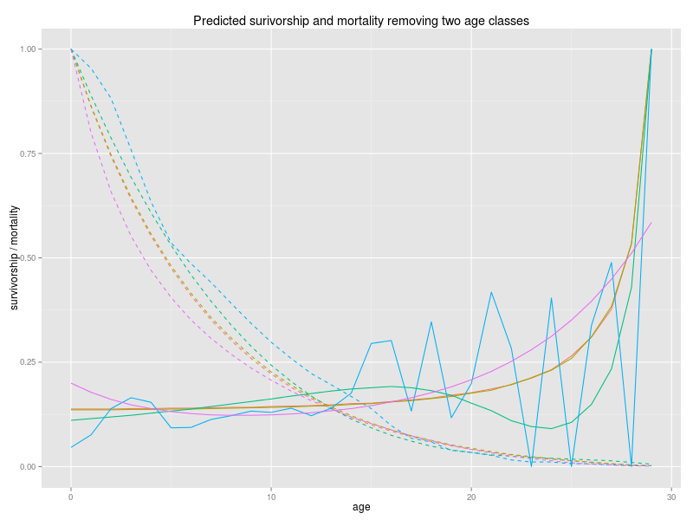
Figure 5: Survivorship and mortality curves from data set with two ages classes removed: Raw data survivorship curve (blue dashed line), raw data mortality curve (blue line), predicted exponential survivorship curve (red dashed line), predicted exponential mortality curve (red line), predicted GLM survivorship curve (brown dashed line), predicted GLM mortality curve (brown line), predicted Siler survivorship curve (purple dashed line), predicted Siler mortality curve (purple line).

Population structure

Once the life tables have been constructed, population structure can be calculate from the 15000 dolphins estimated for the Iberian Peninsula (4/5 of the W block) (SCANS II, 2008) by multiplying the percentage of dolphins per age of the three life tables by the total population (Table 3). Since stable population is assumed and no density dependence or starvation is taken into consideration, total abundance of the population does not affect the dynamics of this, thus no analysis with different abundances will be conducted by the moment.

Table 3: Population structure: Population structure with a total abundance of 15000 dolphins estimated from the total strandings data (lifeN), from the exponential model (lifeExp2), from the GLM (lifeglmPois2), from the polynomial (lifeIIPol2) and from the Siler model with the two first age classes removed (lifeSiler2).

Maturity ogives

Separate ogives for males and females were performed to estimate the amount of mature females in our population. A Binomial GLM used for binary of data (presence-absence, mature-immature) was conducted. Three anomalous data points (immature females older than 10 years) were removed from the dataset and a new female model was rerun without them. The removal of these females was performed assuming that a maturation problem might have occurred by some kind of sickness since these are stranding animals. A50 (age at which half of the dolphins have achieved maturity). Therefore, two ogives were fitted for females, one with the anomalous data points mentioned above and the other without them. The male model did not converge and this may have been due to the scarcity of data available. The A50 were 9.5 and 8.6 for females with and without anomalous data respectively and 7.1 for males (Figure 6).
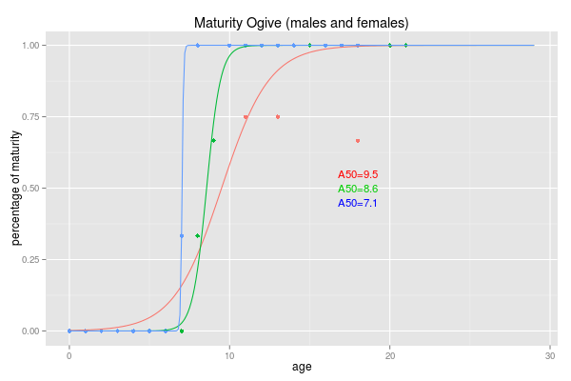
Figure 6: Maturity ogive (males and females). Males maturity ogive (red line), females maturity ogive with all data (blue line) and females maturity ogive where the three anomalous data points were removed (green line). A50 for the two models.

Three maturity vectors are shown in table 4. The table includes the percentage of mature males by sex, the percentage of mature females and the percentage of mature after the three anomalous data points were removed. As in the figure 6, is shown how the slope is very steep in the case of males, whereas in females the slope is small, however it increases after after have removed the anomalous data.

Table 4: Maturity vectors. Percentage of mature dolphins (both sexes combined) and by sex after the three anomalous female data points were removed.

Since the maturity ogive for female, fitted with the corrected data of maturity, will be used in
further analysis, bootstrap with 1000 runs were carried out to calculate the confidence interval 95%
(CI) for the A50. A figure of 8.7 [8.0-9.1] was obtained Although it is believed that the variability
in the estimation of maturity does not have much influence on the population model, sensitivity
analysis will be performed in the future.

Recruitment

It is assumed that the number of males and females in our population is the same or very similar so, sex ratio may be 1:1 or close to it. Therefore, the females abundance per age was obtained by dividing the abundance of dolphins of each age by two. Multiplying this amount by the maturity vector total mature females will be obtained but, since is wanted to get the number of females who could give birth we must to remove the females of each age class which will die in the current year or to move up the maturity vector one year and remove the last age as these dolphins do not give birth next year, assuming approximately a one-year gestation (Murphy, 2013). Furthermore, data must be divided by the pregnancy rate since not all the females will give birth each year. Pregnancy rate is an imprecise index about 25-33% (Murphy, 2013), thus we have calculated the number of birth by applying three different pregnancy rates (25, 33 and 50%). Births estimated by each model are shown in table 5.

Table 5: Number of births. Calculated with three different pregnancy rates (25, 33 and 50%) from the total strandings data (lifeN), from the exponential model (lifeExp2), from the GLM (lifeglmPois2), from the polynomial (lifeIIPol2) and from the Siler model with the two first age classes removed (lifeSiler2).

By catch

The estimated mortality, so far, has been the total mortality of the dolphins off Galician coast. However, as has been seen, total mortality is very high to sustain a stable population. For this reason, was attempted to extract the natural mortality of it to extrapolate it to the whole area and then apply different fishing mortalities according to the fishing effort level of each area.
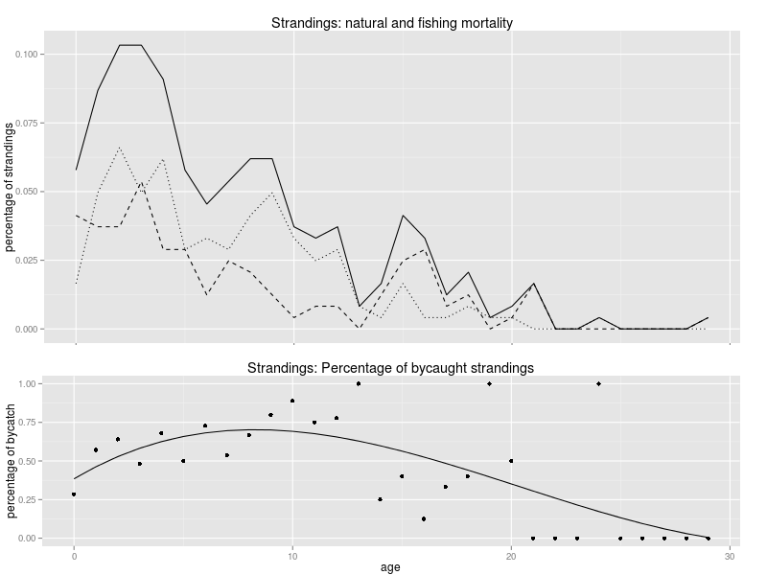
Figure 7: Natural and bycaught strandings: Percentage of total (solid line), natural (dashed line) and bycaught (dotted line) strandings by age [upper graph]. Percentage of bycaught dolphins of the total strandings (dots) and fitted model (solid line) [lower graph].
The first analysis performed was about the patterns of the fishing and natural mortality. Bycaught dolphins were extracted from the total strandings data and their percentages were calculated by age. This analysis showed higher bycatch mortalities at the younger and, conversely in older dolphins (Figure 7). To reduce total mortality in the exactly corresponding fraction was calculated a vector with the percentages of bycaught dolphins by age and applied over the total mortality for this region to obtain natural mortality. This vector proceeds from a third-degree polynomial model fitted to the percentage of the bycaught dolphins.

Sensitivity analysis

Differences between models are not very large, however only Siler model capture the tendency in juvenile mortality. This tendency can vary considerably depending on the number of age classes used for adjustment. Based on this, Siler model fitted with two age classes removed has been considered the best fit and which has most biological sense. Therefore, further analysis will be conducted with it, including sensitivity analysis in the first ages to assess the influence of this adjustment in the whole population.

Sensitivity analysis in the juvenile mortality was conducted varying 25% up and down the value of the intersection of the juvenile curve with the y axis. Note that only the slope of one component of the Siler model, the juvenile mortality, was modified and constant and senescence mortality were not altered. In Figure 8 these curves are graphically represented, red line represents original Siler model while dashed red lines represent slope variations.

Another important source of uncertainty is the related to the percentage of the bycaught dolphins. This analysis might be of particular relevance, since only the dolphins with clear evidences, as net marks or mutilated fins, have been included in the bycaught dolphins. Therefore, it is likely that some dolphins from the other group, which have been attributed a natural death, may have been bycaught, but nevertheless, have no clear signs. This suggests that the percentage of bycatch mortality might be underestimated and therefore, natural mortality will be overestimated.

As outlined in bycatch section, a vector with the percentage of bycaught dolphins of each age was estimated based on a cubic polynomial. Reducing total mortality-at-age in their respective percentage, natural mortality will result. Furthermore this percentage of bycatch for each age have been incremented and reduced by 25% for analysing their uncertainty and consequently three different natural mortalities were calculated. The uncertainties in the adjustment of juvenile mortality was also examined for each of the calculated curves in the same way as in the total mortality. In Figure 8 natural mortality and 25% of variation in its slope, obtained from the original bycatch percentages, is coloured in dark blue, and 25% of variation in the bycatch percentage in light blue.

The third uncertainty point is the pregnancy rate since small variations can greatly affect the recruitment and population stability, thus the number of annual births were calculated with three different pregnancy rates for each model. Population structure is needed for this calculation so, life tables for each model were performed, three for total mortality and nine for natural mortality. In addition to these, values of births for each model were also standardized by the abundance of its age 0, thereby, they can be compared among themselves.

In Table 6 number of births and their standardized values are presented, as well as the mortality-at-age and the population structure for each model, mortalities-at-age were taken from the life tables and population structures were calculated with a total population of 15,000 dolphins as explained in the corresponding section.

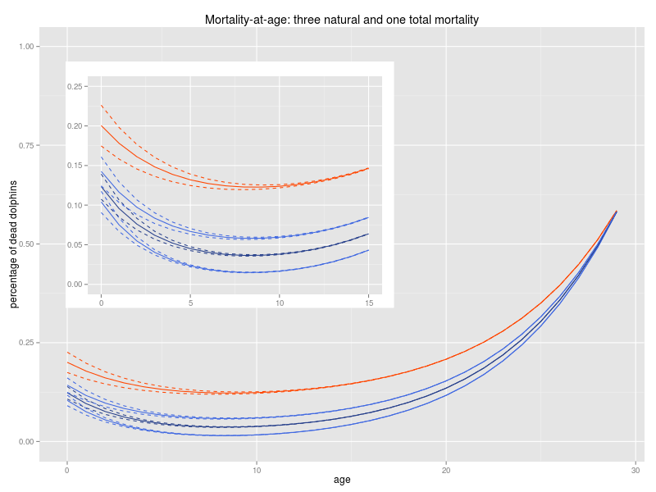
Figure 8: Three different vectors for total mortality and nine for natural mortality: Total mortality with an increment and reduction of 25% of its slope of the juvenile mortality (solid and dashed red lines). Natural mortality calculated by removing bycatch from the total mortality and 25% of variation in its slope (solid and dashed dark blue). Natural mortality calculated with an increment and reduction of 25% of the bycatch calculated for Galicia and 25% of variation in its slope (solid and dashed light blue).

Life tables show how would be a theoretical population structure with a given values of mortality-at-age. If a stable population is assumed, the number of annual deaths must be the same as the number of births. The number of animals of age class 0 represents the annual recruitment for a stable population, therefore, if births are higher the population will grow and if less the population abundance will decrease. Since the distribution of the abundances between ages vary depending the mortality level of each age, total mature females will be different in each population modelled and therefore, the annual births. With the standardized value of births, we know what proportion of their respective age class 0 this births represent. Thus, the standardized value must be at least 100 to achieve the amount of births needed to keep the population stable, however, only a few values in our data satisfy this requirement.

The mortality in the three total mortality models for Galician dolphins are too high, with any slopes analysed, to keep the population stable, and abundance would drastically decrease if this mortality were the same in the whole distribution area (see first columns in Table 6). Only the 15% of the births needed to keep a stable population are achieve if we increase the original slope in 25% and a 25% of pregnancy rate is applied over the females. The maximum percentage of births is reached by reducing 25% the slope and with a 50% of pregnancy rate, but even so, it would be only 38% of the amount needed to keep the population stable.

Table 6: Population structure, mortality-at-age, and number of births: All of this values calculated for three total mortalities (three slopes of juvenile mortality), nine natural mortalities (three levels of bycatch and three different slopes for juvenile mortality each one) and with three different pregnancy rates.

The models of natural mortality, calculated with three levels of bycatch and three slopes each one, only the two with lower mortality could be feasible. These models correspond to that calculated from original bycatch and that calculated from the bycatch increased 25%. In the model where the original bycatch was reduced by 25% only one option would be possible to keep a stable population. With 50% of pregnancy rate the number of birth would reach the amount needed to the stability (103%) but even could de insufficient considering that no fishing mortality is currently being applied. Furthermore, the natural mortality which was calculated with the original percentage of bycaught strandings might not be feasible since needed number of births are only achieved applying a pregnancy rate of 50%, much higher than that found in the literature.

The model may better satisfies the requirements to maintain stability in the population is the third, in which the original bycatch have been increased by 25%. This supports the theory discussed above that the bycatch could be underestimated. Therefore, natural mortality levels estimated by this model probably are the maximum amounts that can accept this population since if the pregnancy rate would be 25% only the model with the slope reduced by 25% in the first ages would be stable. If pregnancy rate would be around 33% all models with the three different slopes would be stables. Even, if had not bycatch in the population, abundance would increase, because number of birth would be between 124% to 135% needed to keep a stable population. However, since there are bycatch in the population this levels would be needed, long as we assume that the population will remain stable.

Analysis of what level of bycatch can withstand our population will be conducted in the following sections.

